AI COMMUNICATION IN LOGISTICS

Practical Lab Report
Name: Ritik Sharma
Roll Number: 2620994562
Batch: I BATCH 2026
Date: 11 October 2026
AI Tool: ChatGPT (OpenAI)

Task 1 — Source-Grounded Prompting
1. Prompt Used
Writing
Using only the supplied shipment information, answer these questions in a table with columns: Question, Answer, Supporting Source Fact.
- What is the current estimated delivery time?
- What caused the delay?
- What recovery action is underway?
- Is the customer eligible to request a delivery-fee review?
- Is a refund already approved?
- Are all cartons confirmed undamaged?
Quote or accurately paraphrase the relevant supplied fact. Where an answer cannot be established, write “Not confirmed from the supplied information.” Do not use outside information or invent details.
2. AI Response
Question | Answer | Supporting Source Fact
1. What is the current estimated delivery time? | 12 October 2026, 6:00 PM. This is an estimate, not a guarantee. | “Current estimated delivery: 12 October 2026, 6:00 PM.”
2. What caused the delay? | A vehicle breakdown during transit. | “Delay reason: Vehicle breakdown during transit.”
3. What recovery action is underway? | A replacement vehicle has been arranged, and cargo transfer is in progress. | “Recovery action: Replacement vehicle arranged; cargo transfer in progress.”
4. Is the customer eligible to request a delivery-fee review? | Yes. The customer may request a review because the revised estimate is eight hours after the original scheduled delivery. | Original scheduled delivery: 10:00 AM. Current estimated delivery: 6:00 PM. Company policy permits a review request for delays of four hours or more.
5. Is a refund already approved? | Not confirmed from the supplied information. | “Refunds require approval and are not automatic.” No refund approval is stated.
6. Are all cartons confirmed undamaged? | Not confirmed from the supplied information. | “Unknown information: confirmed cargo condition.”
3. Screenshot
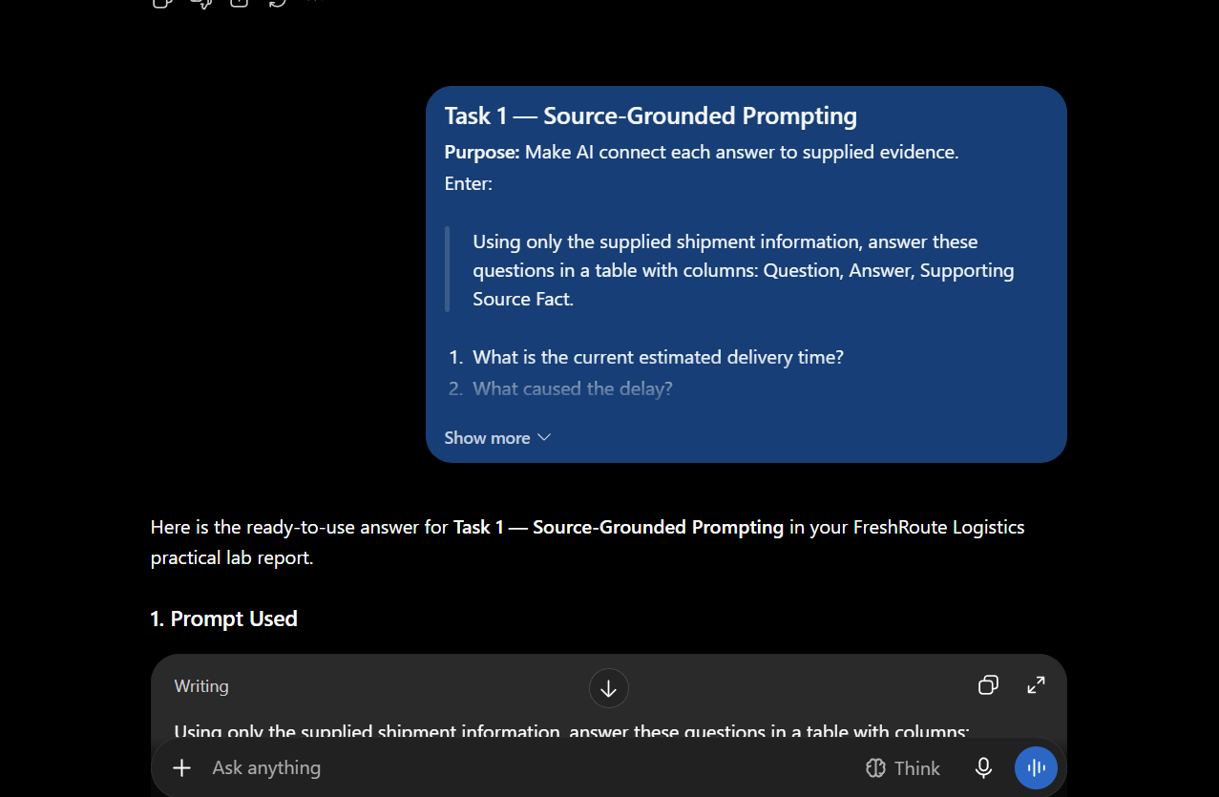
4. Two Examples of Evidence Supporting an Answer
Example 1: Delivery delay
- Answer: The current estimated delivery is 12 October 2026 at 6:00 PM.
- Evidence: The shipment information explicitly lists the current estimated delivery as 6:00 PM.
- Verification: The answer matches the supplied record, and the time is identified as an estimate rather than a guarantee.
Example 2: Refund approval
- Answer: A refund is not confirmed as approved.
- Evidence: Company policy states that refunds require approval and are not automatic.
- Verification: The policy does not establish that a refund has been approved for shipment FR208. Therefore, the response must not promise a refund.
5. Your Check — Observation and Manual Verification
Writing
Observation:
Source-grounded prompting helped the AI produce answers linked to the supplied shipment facts. The supporting-source column made it easier to check whether each answer was accurate. The AI also identified information that could not be confirmed.
Manual Verification:
I compared each answer with the original shipment information. I confirmed that a delivery-fee review is something the customer may request when the delay meets the four-hour threshold. It does not mean that a refund has been approved. I also verified that the cargo condition is unknown, so I cannot claim that all cartons are undamaged.
Conclusion:
Source-grounded prompting improves the reliability and traceability of AI-generated logistics communication. However, every answer must be checked against the original evidence before it is used.

Task 2 — Clarification Prompting
1. Prompt Used
Writing
Before drafting an answer to this customer, identify the missing information. Ask up to three clarification questions for the logistics support team. Do not assume that a refund has been approved. Separate known facts from information requiring confirmation.
Customer asks: “How much refund will I receive, and when will it reach my account?”
Use only the supplied shipment information for FreshRoute Logistics shipment FR208.
2. AI Response
Example response to record and compare with your actual AI output.
Known facts
- Shipment ID: FR208.
- Customer: GreenBasket Retail.
- The current estimated delivery is 12 October 2026 at 6:00 PM.
- Company policy allows customers to request a delivery-fee review for delays of four hours or more.
- Refunds require approval and are not automatic.
Information requiring confirmation
- Whether a refund has been approved.
- The amount, if any, that has been approved.
- The payment timeline, if a refund has been approved.
Three clarification questions for the logistics support team
- Approval status: Has a refund been formally approved for shipment FR208?
- Approved amount: If approved, what is the authorised refund amount?
- Payment timeline: If approved, what is the confirmed processing timeline for the refund?
The available information does not establish a refund amount or payment date. These details must be confirmed before responding to the customer.
3. Screenshot
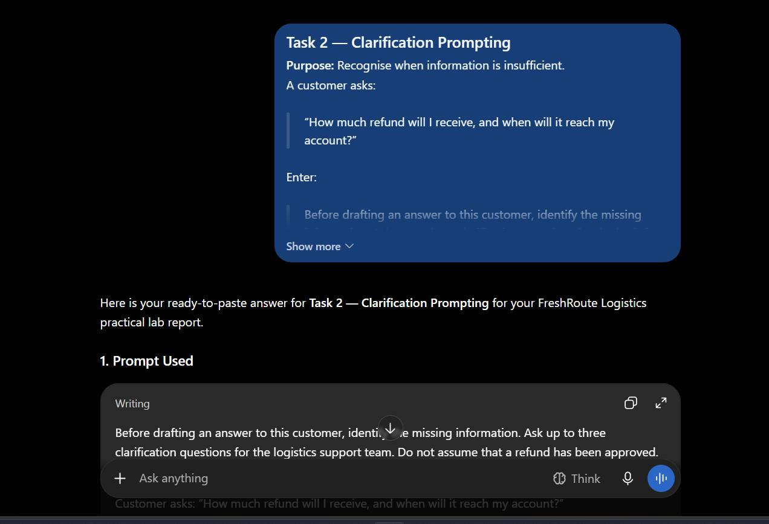
4. Your Check
- Did the AI ask whether the refund was approved? Yes, in the example response.
- Did it ask for the approved refund amount? Yes.
- Did it ask for the payment timeline? Yes.
- Did it avoid promising a refund? Yes.
5. Observation and Manual Verification
Writing
Observation:
Clarification prompting helps identify missing information before an AI drafts a customer response. Instead of guessing the refund amount or payment date, the AI identifies the details that the logistics support team must confirm.
Manual Verification:
I checked the response against the supplied company policy. Refunds require approval and are not automatic. The delivery-fee review policy does not establish that a refund has been approved, and the supplied information contains no approved refund amount or payment timeline.
Why an Immediate Refund Promise Would Be Inappropriate:
Promising a refund amount or payment date without confirmation could mislead the customer and create unrealistic expectations. The support team must first verify approval, the authorised amount and the payment timeline. Only confirmed information should be communicated to the customer.
Conclusion:
Clarification prompting helps prevent unsupported claims and encourages accurate, transparent customer communication in logistics operations.

Task 3 — Catch the Mistakes
1. Prompt Used
Writing
Evaluate this draft against the supplied shipment information. Check factual accuracy, completeness, clarity and professional tone.
Create a table with columns: Claim or Issue, Status, Supporting Evidence, Corrected Wording.
Use these status labels where appropriate: Supported, Contradicted, Unsupported.
Check every timing, guarantee, cargo-condition statement, refund claim and location claim. Do not invent replacement facts.
Draft:
“Dear GreenBasket Retail, your shipment FR208 is guaranteed to arrive today at 4:00 PM. Our driver has confirmed that all cartons are undamaged. A full refund of ₹2,000 has been approved and will reach your account within 24 hours. You can track the vehicle near Jaipur. Your next update will be at 1:00 PM.”
2. AI Response — Mistake Evaluation
Claim or Issue | Status | Supporting Evidence | Corrected Wording
Guaranteed delivery at 4:00 PM | Contradicted | The current estimated delivery is 12 October 2026 at 6:00 PM, and the estimate is not a guarantee. | The current estimated delivery is 12 October 2026 at 6:00 PM. This is an estimate, not a guarantee.
Driver confirmed all cartons are undamaged | Unsupported | Confirmed cargo condition is listed as unknown information. | The cargo condition has not been confirmed in the supplied information.
Full refund of ₹2,000 approved | Unsupported | Refunds require approval and are not automatic. No approval or amount is recorded. | Customers may request a delivery-fee review under company policy. Any refund requires approval.
Refund will arrive within 24 hours | Unsupported | No refund payment timeline is provided. | Any payment timeline must be confirmed by the logistics support team if a refund is approved.
Vehicle can be tracked near Jaipur | Unsupported | The live vehicle location is listed as unknown information. | The live vehicle location is not confirmed in the supplied information.
Next update at 1:00 PM | Contradicted | The verified next customer update is scheduled for 12 October 2026 at 3:00 PM. | The next customer update is scheduled for 12 October 2026 at 3:00 PM.
Missing explanation of the delay | Incomplete | The supplied information identifies a vehicle breakdown during transit. | Explain that a vehicle breakdown during transit caused the delay.
Missing recovery action | Incomplete | A replacement vehicle has been arranged, and cargo transfer is in progress. | Mention the replacement vehicle arrangement and ongoing cargo transfer.
3. Corrected Customer Email
Email
Shipment FR208 — Delivery UpdateShipment FR208 — Delivery Update

Dear GreenBasket Retail,
We are writing to inform you that shipment FR208, containing 100 cartons of packaged biscuits, has been delayed due to a vehicle breakdown during transit.
A replacement vehicle has been arranged, and cargo transfer is in progress. The current estimated delivery time to the Jaipur retail distribution centre is 12 October 2026 at 6:00 PM. Please note that this is an estimate and not a guarantee.
Under our company policy, you may request a delivery-fee review for delays of four hours or more. Any refund requires approval and is not automatic.
Our next customer update is scheduled for 12 October 2026 at 3:00 PM. For assistance, please contact the FreshRoute Logistics support desk.
We apologise for the inconvenience and appreciate your understanding.
Kind regards,
Customer Service Team
FreshRoute Logistics
4. Screenshot
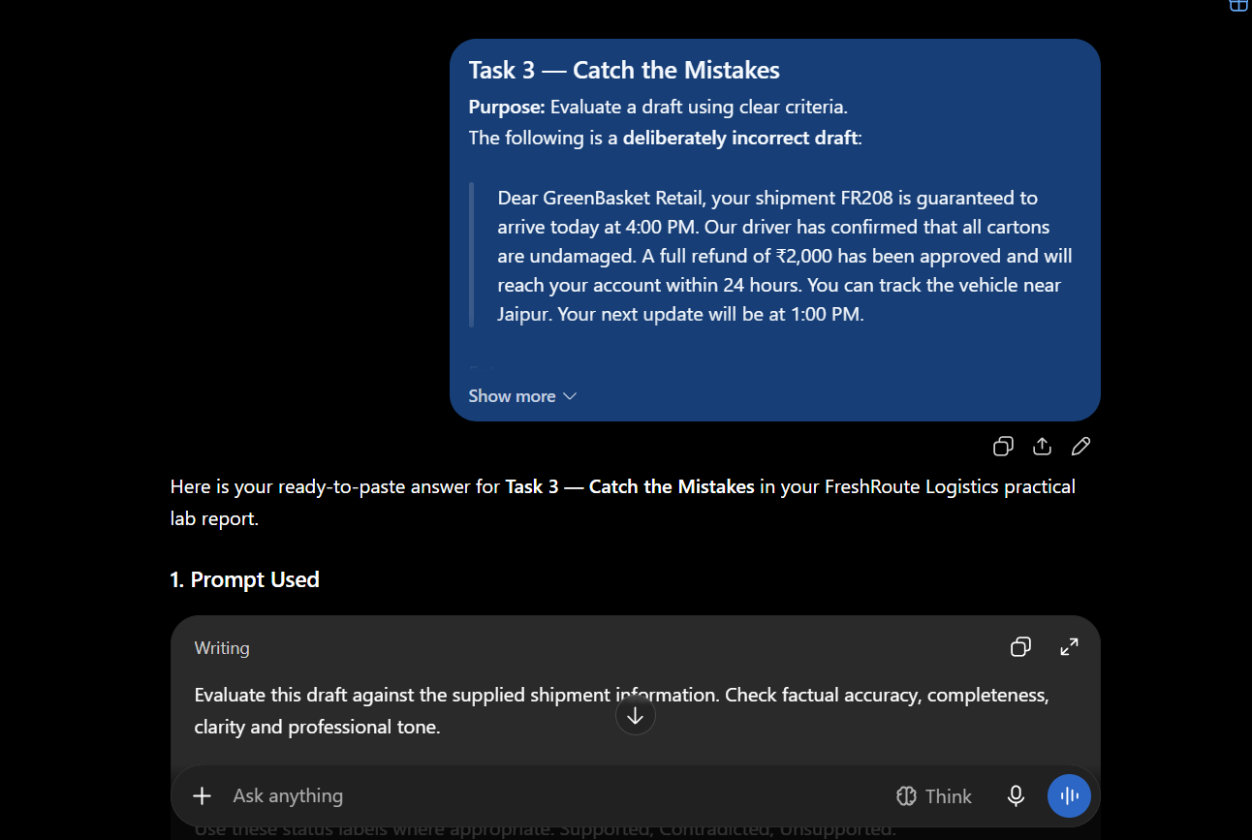
5. Your Manual Check — Observation and Verification
Writing
Observation:
The deliberately incorrect draft contains misleading delivery information, unsupported claims about cargo condition and vehicle location, and an unverified refund promise. Evaluating the draft against the supplied evidence helps identify these errors before the message reaches the customer.
Manual Verification:
I compared every claim with the verified shipment information. I checked the estimated delivery time, delivery guarantee, cargo condition, refund approval, refund amount, payment timeline, vehicle location and next-update time. I also checked whether the draft explained the reason for the delay and the recovery action.
Mistakes the AI Failed to Identify:
After reviewing the AI-generated table, I checked whether it identified all seven specified mistakes and the missing explanation of the delay and recovery action. Any omitted issue should be added manually, supported by the supplied facts. In my final review, I confirmed that the corrected email does not introduce unsupported information.
Conclusion:
This task demonstrates that AI-generated customer communications should be evaluated for factual accuracy, completeness, clarity and professional tone. Human verification is necessary to prevent incorrect commitments and maintain customer trust.

Task 4 — Prompt Chaining
Stage 1 — Prompt A: Correct
Prompt used
Writing
Using the evaluation table, write a corrected customer email within 120 words. Include the current estimated delivery, delay reason, recovery action, next update and delivery-fee review policy. Clearly distinguish estimates from guarantees and review requests from approved refunds.
Example AI response
Email
Shipment FR208 — Delivery Delay UpdateShipment FR208 — Delivery Delay Update

Dear GreenBasket Retail,
We apologise for the delay to shipment FR208, containing 100 cartons of packaged biscuits, due to a vehicle breakdown during transit.
A replacement vehicle has been arranged, and cargo transfer is in progress. The current estimated delivery to the Jaipur retail distribution centre is 12 October 2026 at 6:00 PM. This is an estimate, not a guarantee.
Under company policy, you may request a delivery-fee review for delays of four hours or more. Any refund requires approval and is not automatic.
Our next customer update is scheduled for 12 October 2026 at 3:00 PM.
For assistance, please contact the FreshRoute Logistics support desk.
Kind regards,
FreshRoute Logistics Customer Service Team
Purpose of Stage 1: To correct the original draft and produce a professional customer email using the verified shipment information.
Screenshot: 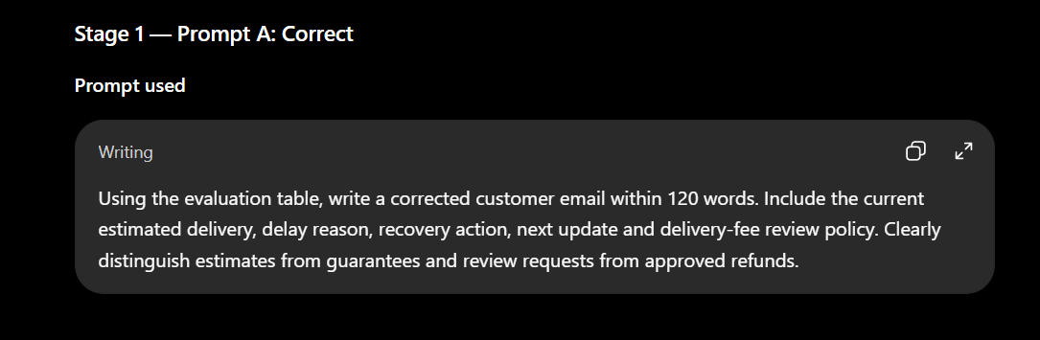
Stage 2 — Prompt B: Review
Prompt used
Writing
Check the corrected email against the supplied source information. List any remaining unsupported claims, incorrect timings or missing required details. If none are found, state that clearly. Do not treat your earlier output as evidence.
Example AI response
Check | Result | Verification
Shipment ID and customer | Supported | Shipment FR208 and GreenBasket Retail match the supplied information.
Delay reason | Supported | Vehicle breakdown during transit.
Recovery action | Supported | Replacement vehicle arranged; cargo transfer in progress.
Estimated delivery | Supported | 12 October 2026, 6:00 PM; correctly described as an estimate.
Next update | Supported | 12 October 2026, 3:00 PM.
Delivery-fee review policy | Supported | Customers may request a review for delays of four hours or more.
Refund promise | No unsupported promise found | The email correctly states that refunds require approval and are not automatic.
Missing required information | None identified | All details required by Prompt A are included.
Review conclusion: No remaining unsupported claims, incorrect timings or missing required details were identified in this example email.
Purpose of Stage 2: To check the first email against the original source facts and identify errors or missing information before finalising it.
Screenshot: 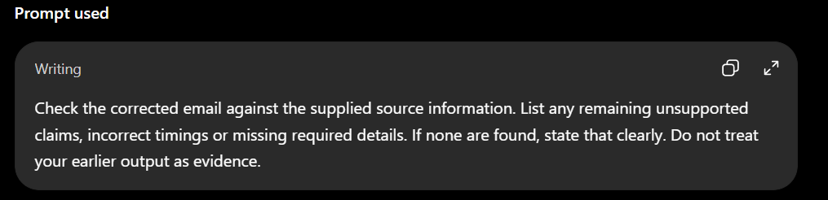
Stage 3 — Prompt C: Finalise
Prompt used
Writing
Apply any necessary corrections and provide the final email with a subject line. Then create a customer SMS within 50 words containing the shipment ID, current estimated delivery and next update.
Final customer email
Email
Shipment FR208 — Delivery UpdateShipment FR208 — Delivery Update

Dear GreenBasket Retail,
We apologise for the delay to shipment FR208, containing 100 cartons of packaged biscuits, due to a vehicle breakdown during transit.
A replacement vehicle has been arranged, and cargo transfer is in progress. The current estimated delivery to the Jaipur retail distribution centre is 12 October 2026 at 6:00 PM. This is an estimate, not a guarantee.
Under company policy, you may request a delivery-fee review for delays of four hours or more. Any refund requires approval and is not automatic.
Our next customer update is scheduled for 12 October 2026 at 3:00 PM.
For assistance, please contact the FreshRoute Logistics support desk.
Kind regards,
FreshRoute Logistics Customer Service Team
Final customer SMS
Message
Update on shipment FR208: The current estimated delivery is 12 October 2026 at 6:00 PM. Our next update is scheduled for 3:00 PM on 12 October 2026. The delivery estimate is not guaranteed. We apologise for the inconvenience.
Purpose of Stage 3: To incorporate any necessary corrections and produce the final email and a short SMS suitable for customer communication.
Screenshot: Capture Prompt C, the final email and the SMS.
Manual verification checklist
Verification progress
0 of 7
The email uses the correct shipment ID and customer name.
The 6:00 PM delivery time is labelled as an estimate, not a guarantee.
The vehicle breakdown and replacement-vehicle action are accurate.
The next customer update is 3:00 PM on 12 October 2026.
The fee review is a request option, not an automatic refund.
The SMS contains the shipment ID, estimated delivery and next update.
The SMS is within the 50-word limit.
Observation and conclusion
Writing
Observation:
Prompt chaining divided the communication task into three connected stages: correction, review and finalisation. Each stage had a specific purpose and helped organise the process of producing accurate customer communication.
Manual Verification:
I compared the final email and SMS with the original shipment information. I verified the shipment ID, delivery estimate, delay reason, recovery action and next-update time. I also confirmed that the delivery-fee review policy did not become an unauthorised refund promise.
Conclusion:
Prompt chaining can improve the structure and consistency of AI-generated logistics communication. However, reviewing an AI response does not guarantee its accuracy. The final email and SMS must still be checked against the original verified facts before use.

Task 5 — Multilingual Prompting
1. Prompt Used
Writing
Translate the final customer SMS into simple, professional Hindi. Preserve shipment ID FR208, the date, estimated delivery time and next-update time exactly. Retain the meaning of “estimated”; do not turn it into a guaranteed arrival. Do not add new information.
English SMS:
Update on shipment FR208: The current estimated delivery is 12 October 2026 at 6:00 PM. Our next update is scheduled for 3:00 PM on 12 October 2026. The delivery estimate is not guaranteed. We apologise for the inconvenience.
2. AI Response — Hindi SMS
Message
शिपमेंट FR208 के संबंध में अपडेट: वर्तमान अनुमानित डिलीवरी 12 अक्टूबर 2026 को शाम 6:00 बजे है। अगला अपडेट 12 अक्टूबर 2026 को दोपहर 3:00 बजे दिया जाएगा। डिलीवरी का यह समय अनुमानित है, इसकी गारंटी नहीं है। असुविधा के लिए हमें खेद है।
3. English and Hindi Comparison Table
Check | Your finding
Shipment ID remains FR208 | Pass — The Hindi version retains FR208 exactly.
Estimated delivery remains 6:00 PM | Pass — The Hindi version states शाम 6:00 बजे.
Next update remains 3:00 PM | Pass — The Hindi version states दोपहर 3:00 बजे.
Date remains 12 October 2026 | Pass — Both dates remain 12 अक्टूबर 2026.
No new promise has been added | Pass — The Hindi version clearly states that the delivery time is not guaranteed.
Meaning remains clear and accurate | Pass — The message preserves the delivery estimate, next update and apology.
4. Screenshot
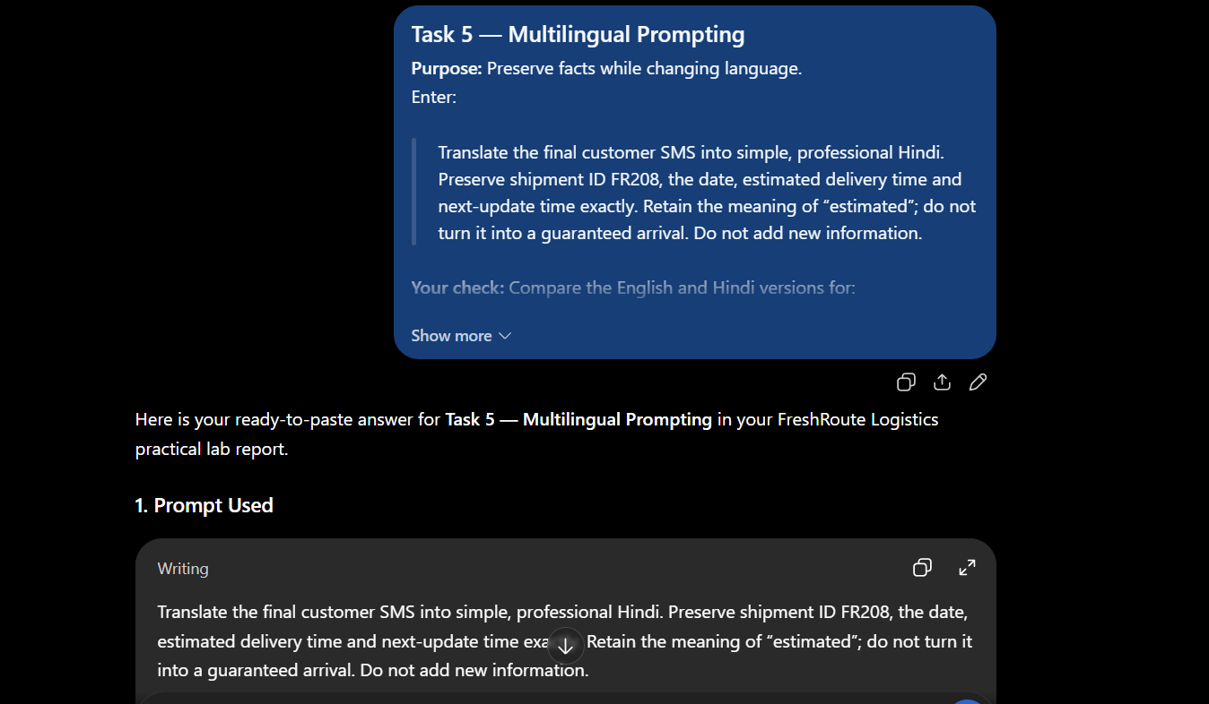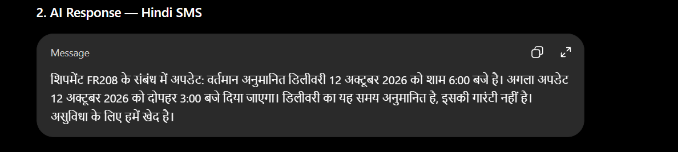
5. Observation and Manual Verification
Writing
Observation:
Multilingual prompting enabled the English customer SMS to be translated into simple, professional Hindi while preserving the key shipment details. The translated message remained clear and appropriate for customer communication.
Manual Verification:
I compared the English and Hindi versions to verify that the shipment ID remained FR208, the estimated delivery remained 12 October 2026 at 6:00 PM, and the next update remained 12 October 2026 at 3:00 PM. I also checked that the Hindi wording communicated an estimate rather than a guaranteed arrival and did not introduce any new information.
Conclusion:
Multilingual prompting helps logistics companies communicate with customers in different languages. However, translations must be checked to ensure that dates, times, shipment identifiers and important conditions retain their original meaning.

Task 6 — Reusable Prompt Template
1. Reusable Prompt Template — Editable Text
Copy this template into your Word document. You can reuse it for different shipments by replacing the placeholders.
Writing
Reusable Customer Delivery-Delay Email Prompt
Act as a professional logistics customer service executive for [COMPANY].
Using only the supplied information, write a professional customer delivery-delay email addressed to [CUSTOMER] about shipment [SHIPMENT_ID].
Shipment details
- Goods: [GOODS]
- Route: [ROUTE]
- Scheduled delivery: [SCHEDULED_DELIVERY]
- Current estimated delivery: [ESTIMATED_DELIVERY]
- Delay reason: [DELAY_REASON]
- Recovery action: [RECOVERY_ACTION]
- Next customer update: [NEXT_UPDATE]
- Company policy: [POLICY]
- Unknown information: [UNKNOWN_INFORMATION]
Instructions
- Provide a clear, professional subject line.
- Write an email of no more than 120 words.
- Use only the supplied facts. Do not invent details or carry over information from other shipments.
- Clearly distinguish estimated delivery times from guaranteed arrivals. Never guarantee an arrival time.
- Do not promise compensation or a refund unless approval is explicitly confirmed in the supplied information.
- Explain the delay and recovery action accurately.
- Include the next customer update and relevant company policy.
- If information required to produce an accurate email is missing, flag it for clarification rather than guessing.
- Do not present unknown information as confirmed.
- Before finalising, check the shipment ID, customer, dates, times, policy and all factual claims against the supplied information.
Return the subject line and final email only, unless clarification is required. If clarification is required, identify the missing information clearly.
2. Completed Prompt for Test Shipment FR315
Writing
Act as a professional logistics customer service executive for FreshRoute Logistics.
Using only the supplied information, write a professional customer delivery-delay email addressed to HomeStyle Retail about shipment FR315.
Shipment details
- Goods: 40 cartons of kitchen utensils
- Route: Pune → Mumbai
- Scheduled delivery: 14 October 2026, 11:00 AM
- Current estimated delivery: 14 October 2026, 2:00 PM
- Delay reason: Traffic congestion
- Recovery action: Dispatch team is monitoring progress
- Next customer update: 14 October 2026, 12:30 PM
- Company policy: Delivery-fee review may be requested for delays of four hours or more; refunds require approval.
- Unknown information: Live location and confirmed cargo condition.
Instructions
- Provide a clear subject line and an email within 120 words.
- Use only the supplied facts. Do not invent details or carry over information from other shipments.
- Clearly distinguish estimated delivery from guaranteed arrival.
- Do not promise compensation or a refund.
- Include the delay reason, recovery action, next customer update and relevant policy.
- Do not claim the vehicle's location or cargo condition is confirmed.
- If information required for an accurate email is missing, flag it for clarification.
- Verify all shipment details and policy statements before finalising.
The estimated delay is three hours. Do not claim that the customer qualifies for a delivery-fee review based on these facts.
3. Expected AI Output
Email
Shipment FR315 — Delivery UpdateShipment FR315 — Delivery Update

Dear HomeStyle Retail,
We would like to inform you that shipment FR315, containing 40 cartons of kitchen utensils travelling from Pune to Mumbai, has been delayed due to traffic congestion.
The dispatch team is monitoring progress. The current estimated delivery is 14 October 2026 at 2:00 PM. This is an estimate, not a guarantee.
Our next customer update is scheduled for 14 October 2026 at 12:30 PM.
Under company policy, a delivery-fee review may be requested for delays of four hours or more. The current three-hour delay does not establish eligibility under this policy. Any refund requires approval.
For assistance, please contact the FreshRoute Logistics support desk.
Kind regards,
FreshRoute Logistics Customer Service Team
4. Output Verification
Verification check | Finding
Correct customer and shipment | Pass — HomeStyle Retail, FR315
Correct goods and route | Pass — 40 cartons of kitchen utensils, Pune → Mumbai
Correct estimated delivery | Pass — 14 October 2026, 2:00 PM
Estimated delay | Pass — Three hours after the scheduled 11:00 AM delivery
Delivery-fee review eligibility | Pass — The facts do not establish eligibility under the four-hour threshold
Refund promise | Pass — No refund is promised; approval is required
Unknown information | Pass — No live location or cargo condition is invented
Next update | Pass — 14 October 2026, 12:30 PM
Email length | Pass — Within 120 words
5. Screenshot and Manual Verification
Screenshot: 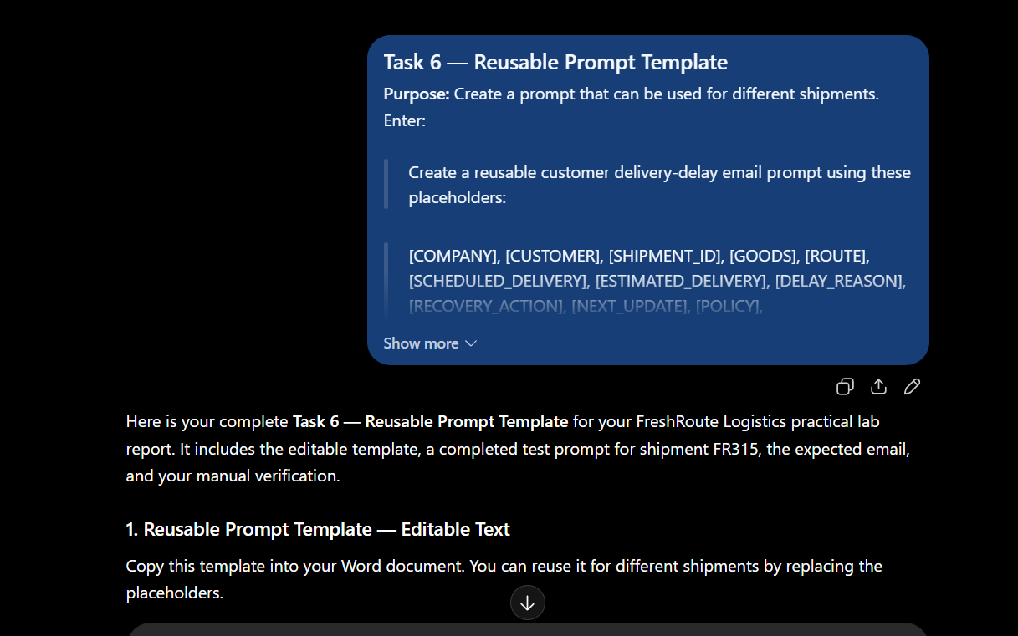
Writing
Observation:
The reusable prompt template provides a consistent structure for creating customer delivery-delay emails for different shipments. Placeholders make it easier to update shipment details without rewriting the entire prompt.
Manual Verification:
I verified the shipment ID, customer name, goods, route, delivery schedule, estimated delivery and next-update time. The delay is three hours, from 11:00 AM to 2:00 PM. Since the supplied policy requires a delay of four hours or more for a delivery-fee review request, these facts do not establish eligibility. I also confirmed that the email does not invent a vehicle location, claim the cargo condition is confirmed, or promise a refund.
Conclusion:
Reusable prompt templates improve consistency and reduce the risk of factual errors in logistics communication. However, every completed prompt and AI-generated response must be checked against the specific shipment's verified information.

